|  |  |  |  |
| --- | --- | --- | --- |
| Test Description | Test data | Actual result | Expected result |
| Checking interaction between login page and home page | Enter mailid:  [ranjitha@gmail.com](mailto:ranjitha@gmail.com)  Password:ran12@ | Redirected to Gmail home page | Redirected to Gmail home page |
| Checking dataflow between inbox and bin | Select any mail from inbox and click on delete | The deleted mail is added to bin | The deleted mail is added to bin |
| Check the data flow between inbox and category | Select any mail in inbox and click on label as and select any category ex:  updates | The selected mail is added to category update | The selected mail is added to category update |
| Checking data flow between the search bar and inbox mails | Enter any key element of the mail in search bar | It is redirected to inbox mails and it will search for that particular key element | It is redirected to inbox mails and it will search for that particular key element |
| Checking data flow between bin and inbox | Select mail in bin and click on move to and select inbox | The selected mail is moved to inbox | The selected mail is moved to inbox |
| Check data flow between inbox and snooze | Select any mail and click on snooze and select snooze until | The selected mail id is added to snooze | The selected mail id is added to snooze |
| Checking data flow between compose mail and sent items | Enter to address:  [ranjitha@gmail.com](mailto:ranjitha@gmail.com)  And enter body of the mail and click on send | The composed mail is redirected to sent items | The composed mail is redirected to sent items |
| Checking data flow between compose mail and sent items | Enter to address:  1234  Enter body of the mail and click on send | The composed mail is not redirected to sent items , it will show that the entered address is not found | The composed mail is not redirected to sent items , it will show that the entered address is not found |
| Checking data flow between the search bar and inbox mails | Enter any key element in search bar for example:0000000000000000 | It is redirected to inbox mails and it will search particular key element and gives message as no message matched your search | It is redirected to inbox mails and it will search particular key element and gives message as no message matched your search |
| Checking data flow between starred and inbox | Select the mail in starred and unselect star | The selected mail is unselected from star in inbox also | The selected mail is unselected from star in inbox also |
| Check the data flow between composing mail and drafts | Compose any mail and do not send that mail | The composed mail will be stored to drafts | The composed mail will be stored to drafts |
| Check the data flow between spam and bin | Select any mail present in spam mails and click on delete | The deleted mail is added to bin | The deleted mail is added to bin |
| Check the dataflow between inbox and starred | Select any mail in inbox and click on starred | The selected mail is added to starred | The selected mail is added to starred |
| Checking interaction between new meeting and chrome | When we click on new meeting | It is redirecting to chrome page and generates the meeting url | It is redirecting to chrome page and generates the meeting url |
|  |  |  |  |

Java programs

**1.** Write a Java program to print 'Hello' on screen and then print your name on a separate line.   
*Hello*  
*Alexandra Abramov*

*import java.util.*;*

*public class MyClass {*

*public static void main(String args[]) {*

*System.out.println("Hello "+"\nRanjitha");*

*}*

*}*

*p*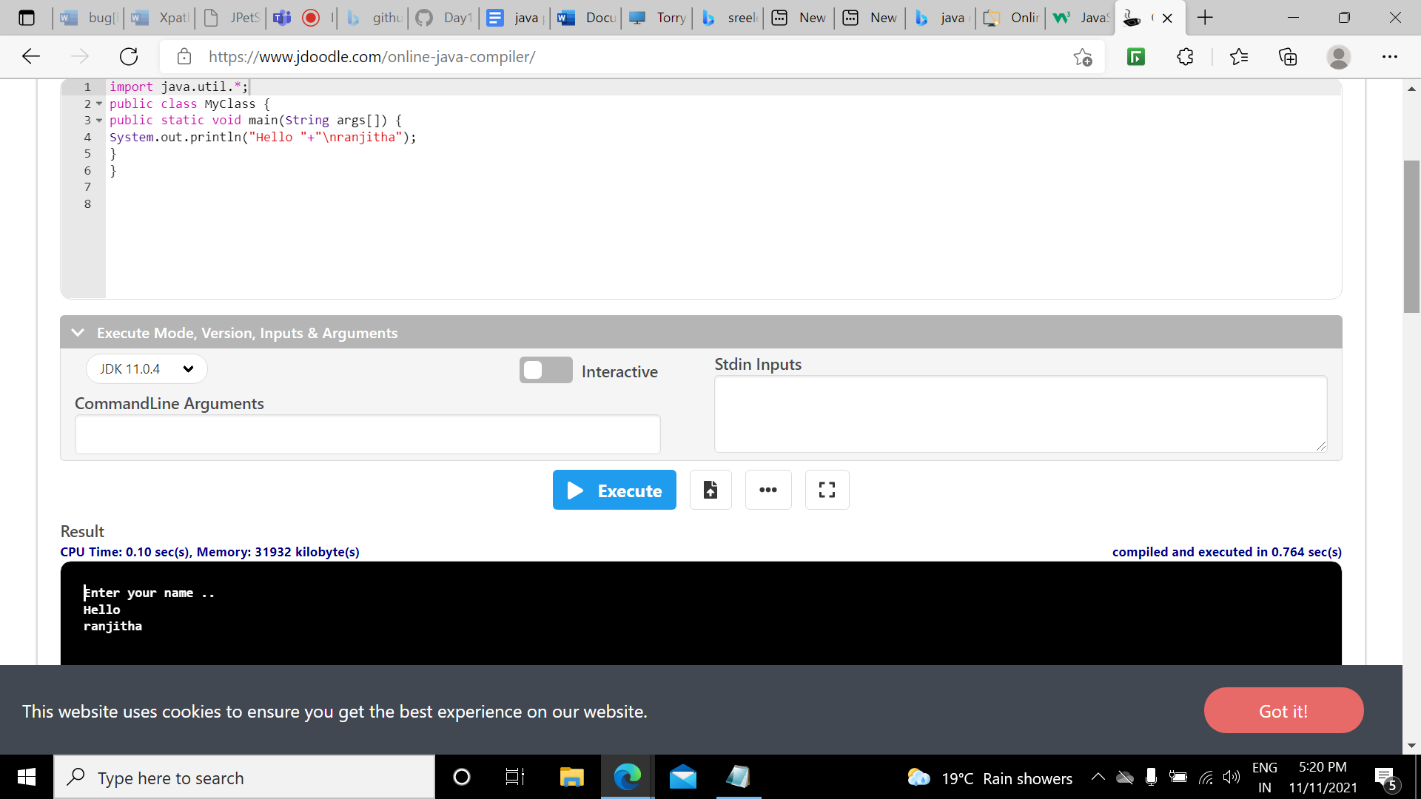

**2.** Write a Java program to print the sum of two numbers   
Test Data:  
74 + 36  
Expected Output :  
110

public class MyClass {

public static void main(String args[]) {

int x=74;

int y=36;

int z=x+y;

System.out.println("Sum of x and y = " + z);

}

}

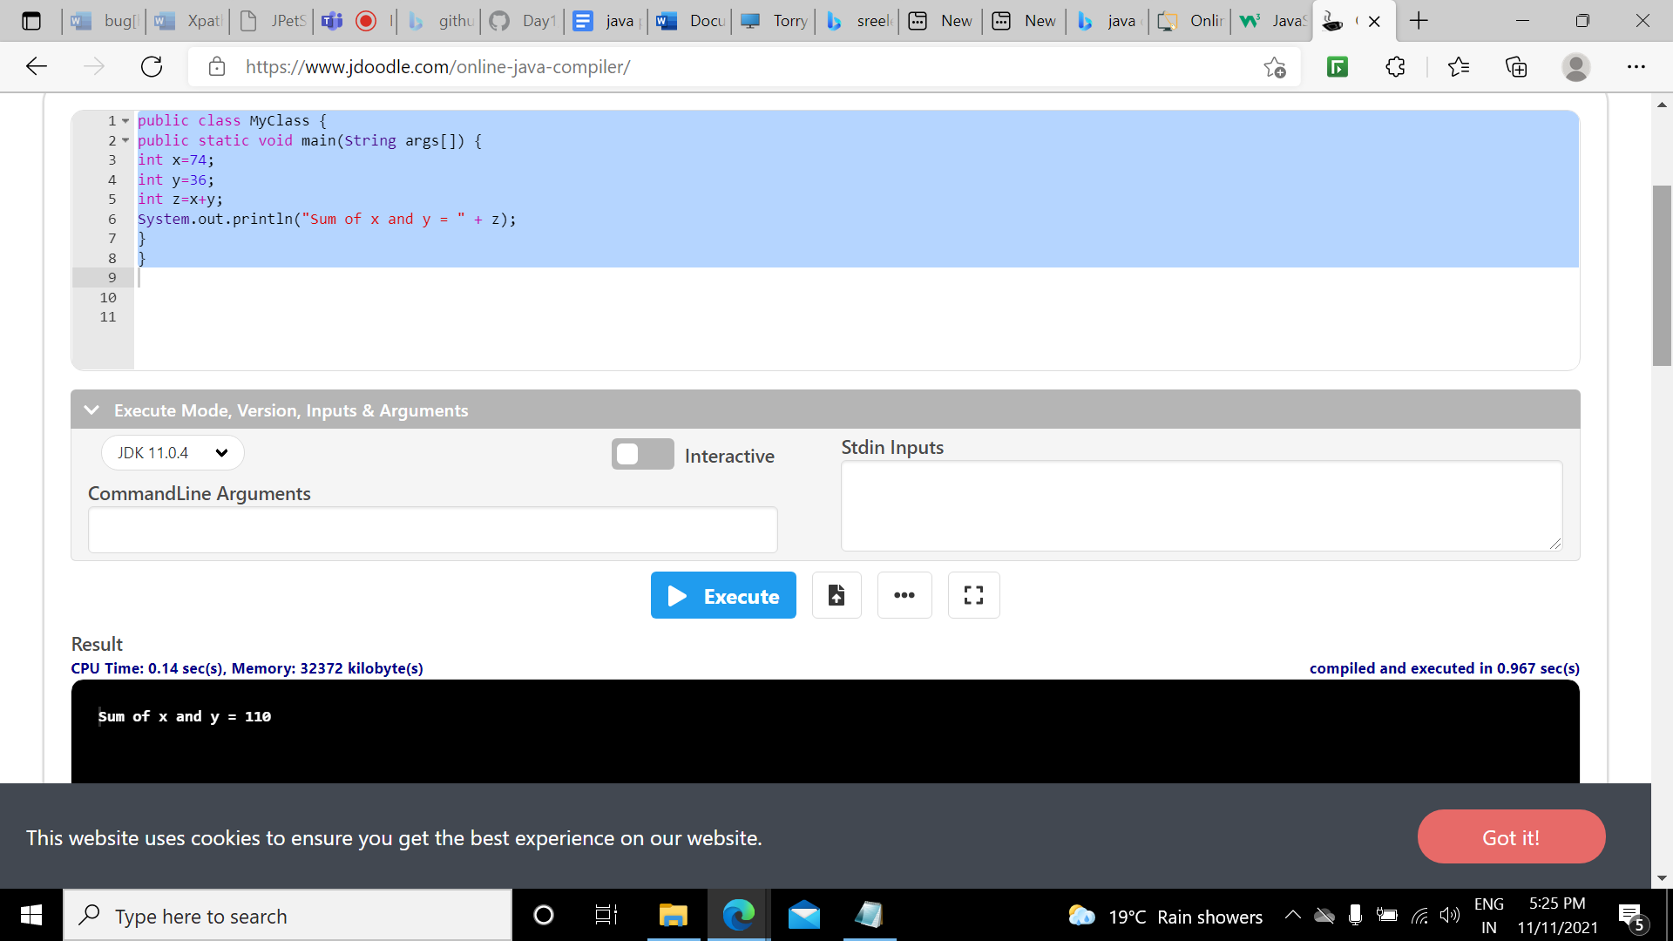

**3.** Write a Java program that takes two numbers as input and display the product of two numbers.   
Test Data:  
Input first number: 25  
Input second number: 5  
Expected Output :  
25 x 5 = 125

import java.util.*;

public class MyClass {  
public static void main(String args[]) {  
Scanner sc = new Scanner(System.in);  
double num1 = sc.nextInt();  
double num2 = sc.nextInt();  
double Result = num1 * num2;

System.out.println(“The product of two numbers is:”+Result);  
}  
}

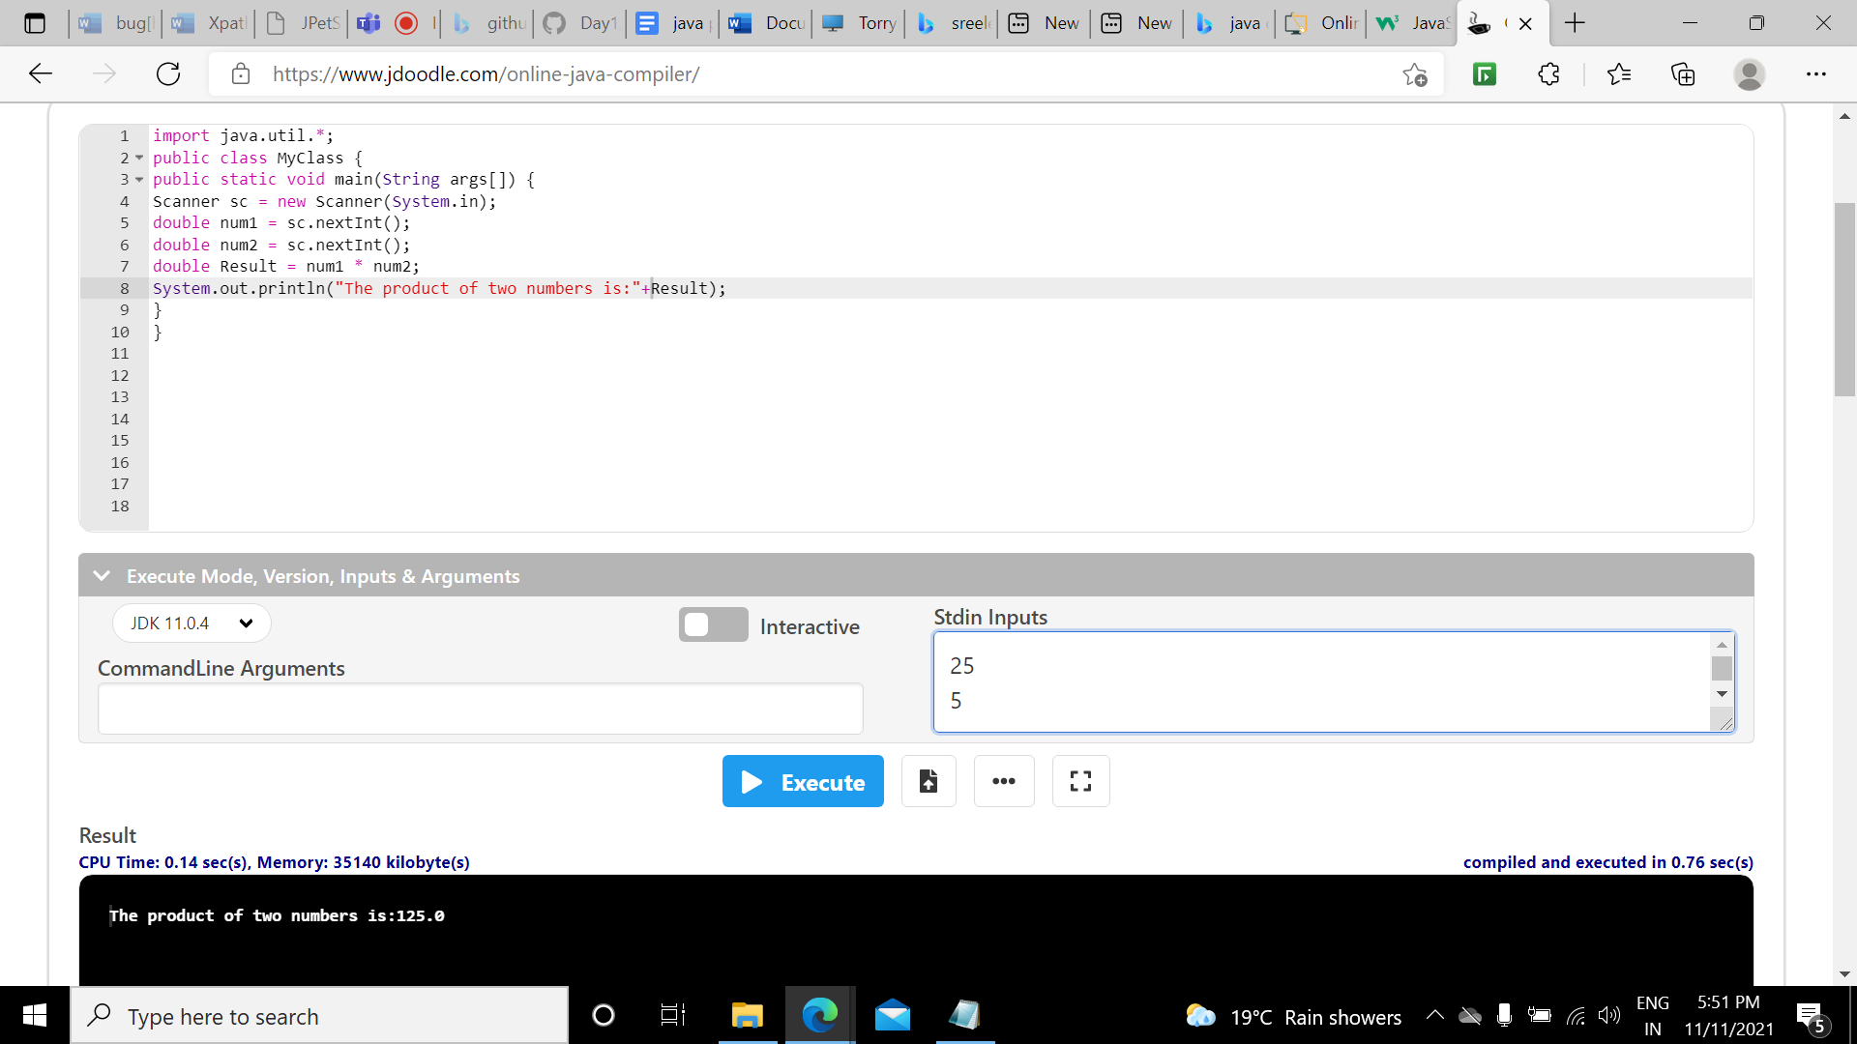

4. Write a Java program that takes a number as input and prints its multiplication table upto 10.  
Test Data:  
Input a number: 8  
Expected Output :  
8 x 1 = 8  
8 x 2 = 16  
8 x 3 = 24  
...  
8 x 10 = 80

import java.util.*;

public class MyClass {  
public static void main(String args[]) {  
Scanner sc = new Scanner(System.in);  
System.out.println("Enter the number ");  
int num = sc.nextInt();  
int res;  
for(int i = 0; i<=10; i++){  
res = num * i;  
System.out.println(num +" "+"* "+" "+i +" = "+ res);  
}  
}  
}

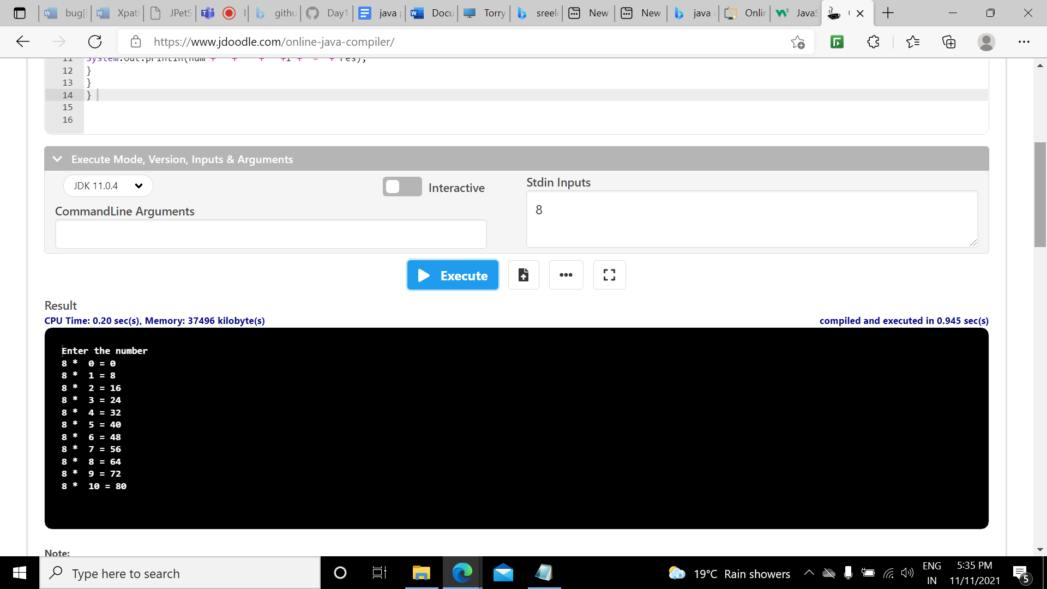

5. Write a Java program to print the sum (addition), multiply, subtract, divide and remainder of two numbers.  
Test Data:  
Input first number: 125  
Input second number: 24  
Expected Output :  
125 + 24 = 149  
125 - 24 = 101  
125 x 24 = 3000  
125 / 24 = 5  
125 mod 24 = 5

import java.util.*;

public class MyClass {

public static void main(String args[]) {

Scanner sc = new Scanner(System.in);

double num1 = sc.nextInt();

double num2 = sc.nextInt();

double Product = num1 * num2;

double Sum = num1 + num2;

double Sub = num1 - num2;

double Mod = num1 % num2;

double Div = num1/num2;

System.out.println("The product is:"+Product+"\nThe sum is:"+Sum+ "\nThe Subtraction is:"+ Sub +"\nThe Modulus is:"+Mod+ " \nThe division is:"+Div);

}

}

